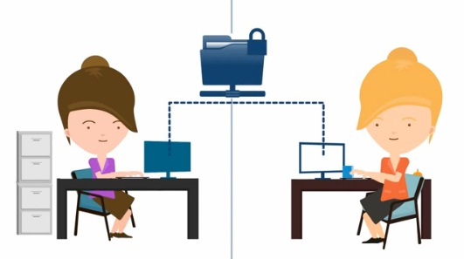

GP2GP: the Electronic Transfer of Patient Records
By the end of March 2015 your GP practice will able to send computer held patient records electronically to a patient's new surgery so they arrive much quicker than the paper notes, helping the doctors and nurses know the best way to treat you. This is called the GP2GP electronic transfer of patient records. The paper notes will continue to be sent via an NHS delivery service.
With GP2GP, your medical record is available to your new doctor within a few minutes of registration, enabling much safer care.
For more information about GP2GP visit the HSCIC website at http://systems.hscic.gov.uk/gp2gp

